Eufy E40 Camera Housing – Installation Guide
Installing the camera into the internal holder

Step 1: Angle the front of the camera downward and place it into the camera holder.
Step 2: Slide the camera into the holder, straighten the camera, and then slide it forward until it is seated securely in the camera holder.
Note: The camera should sit level and snug inside the holder before the housing is closed.
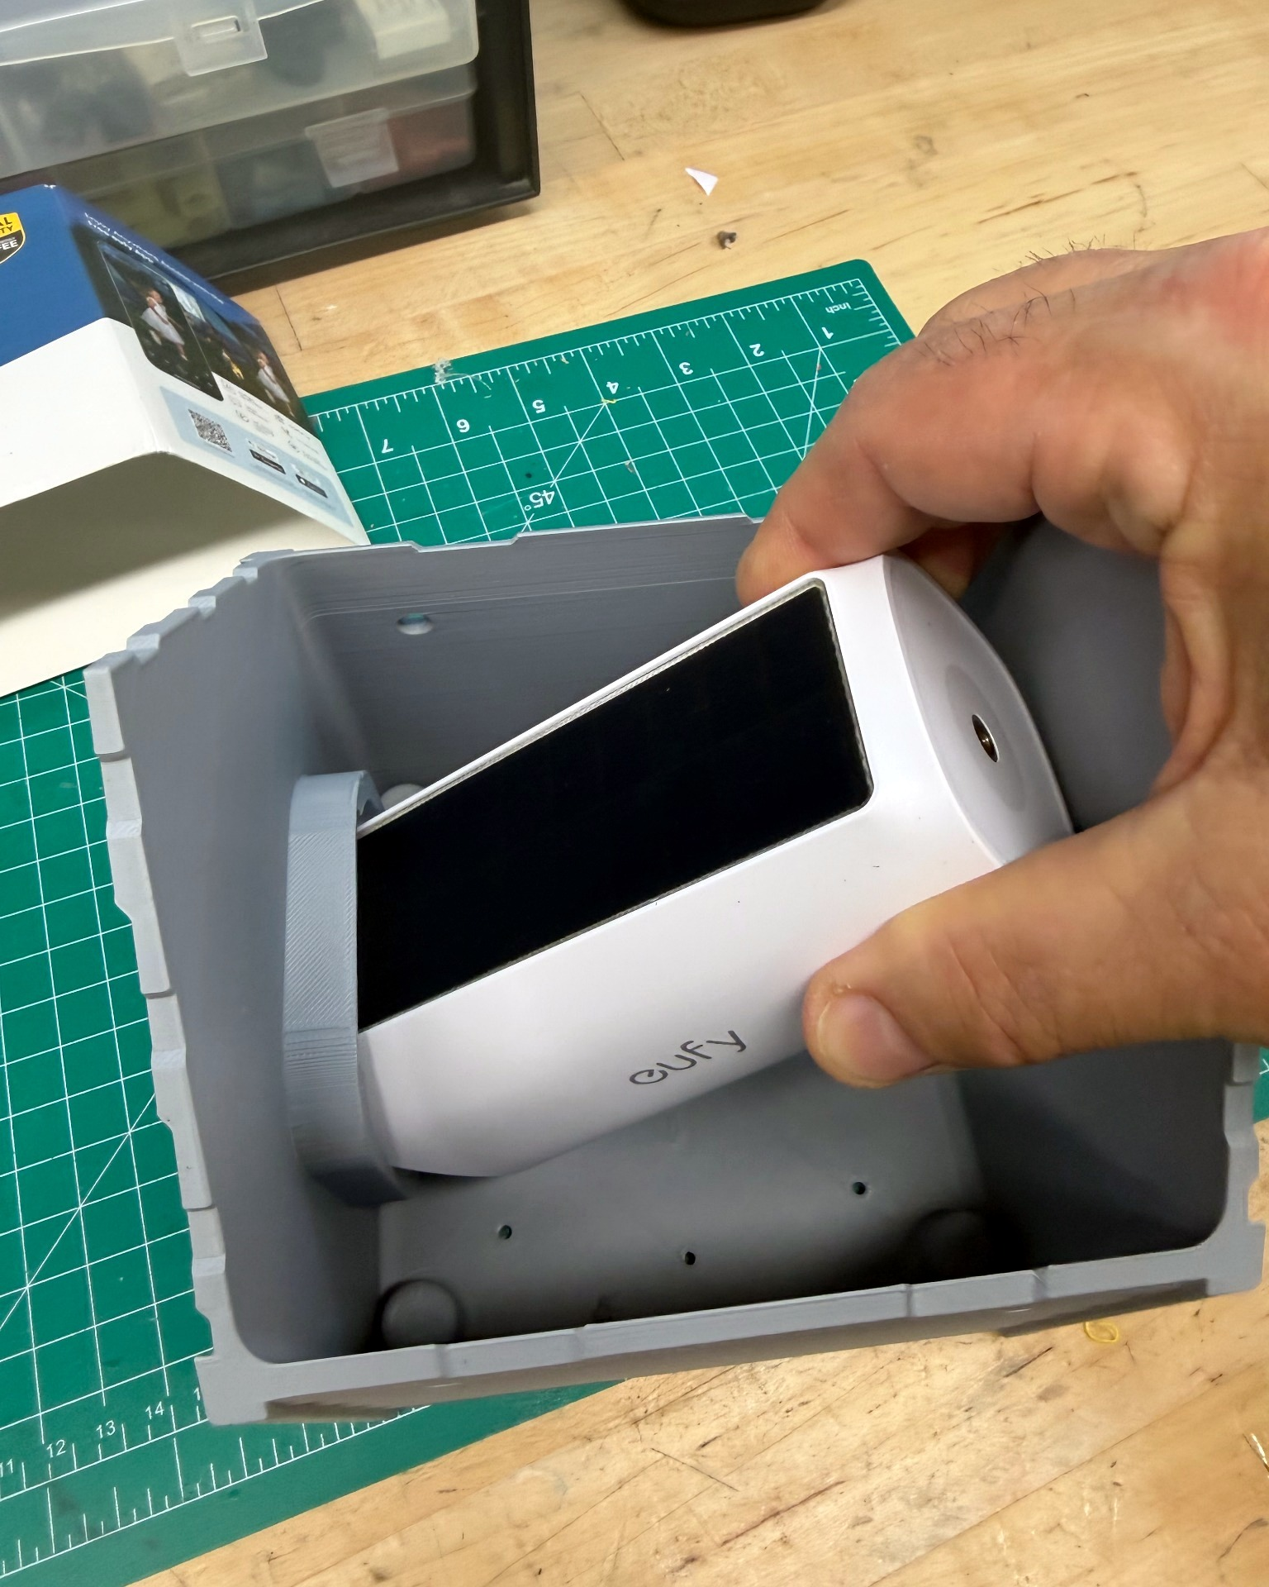 | 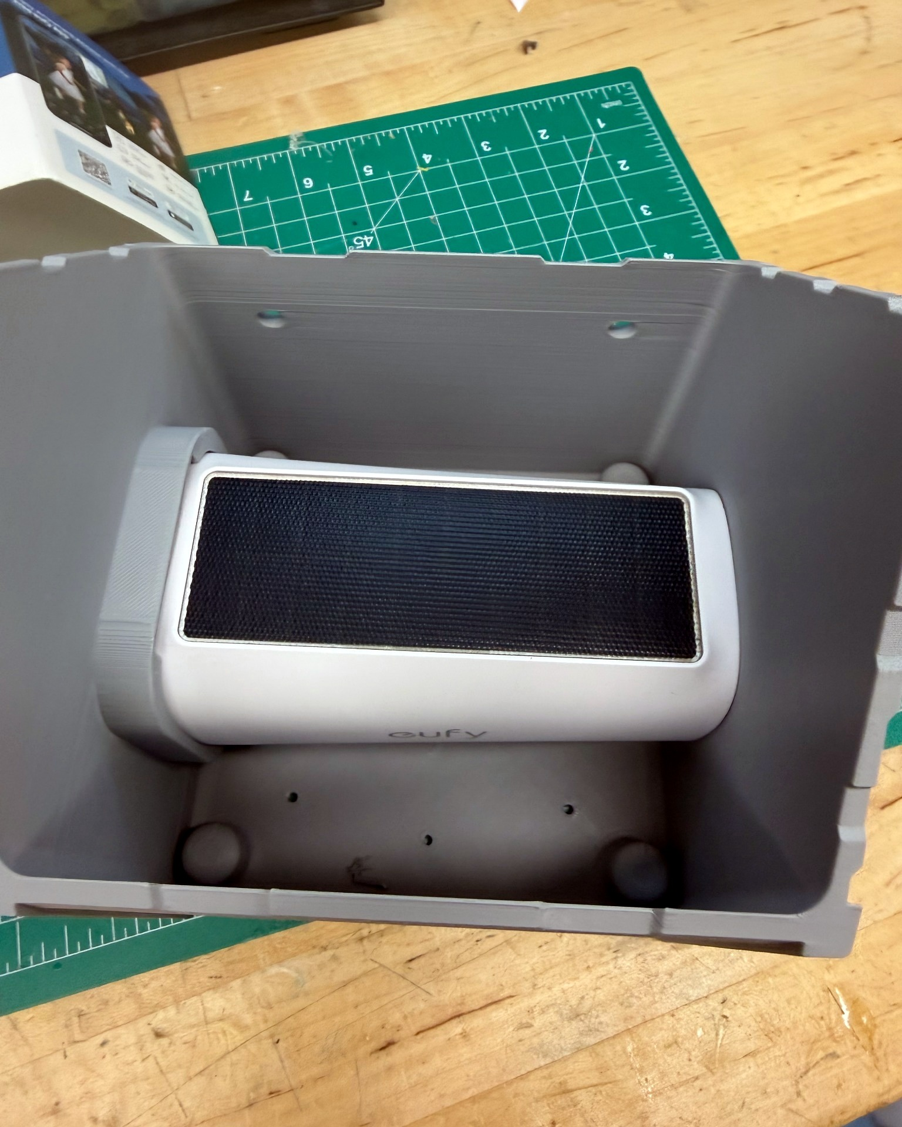 | 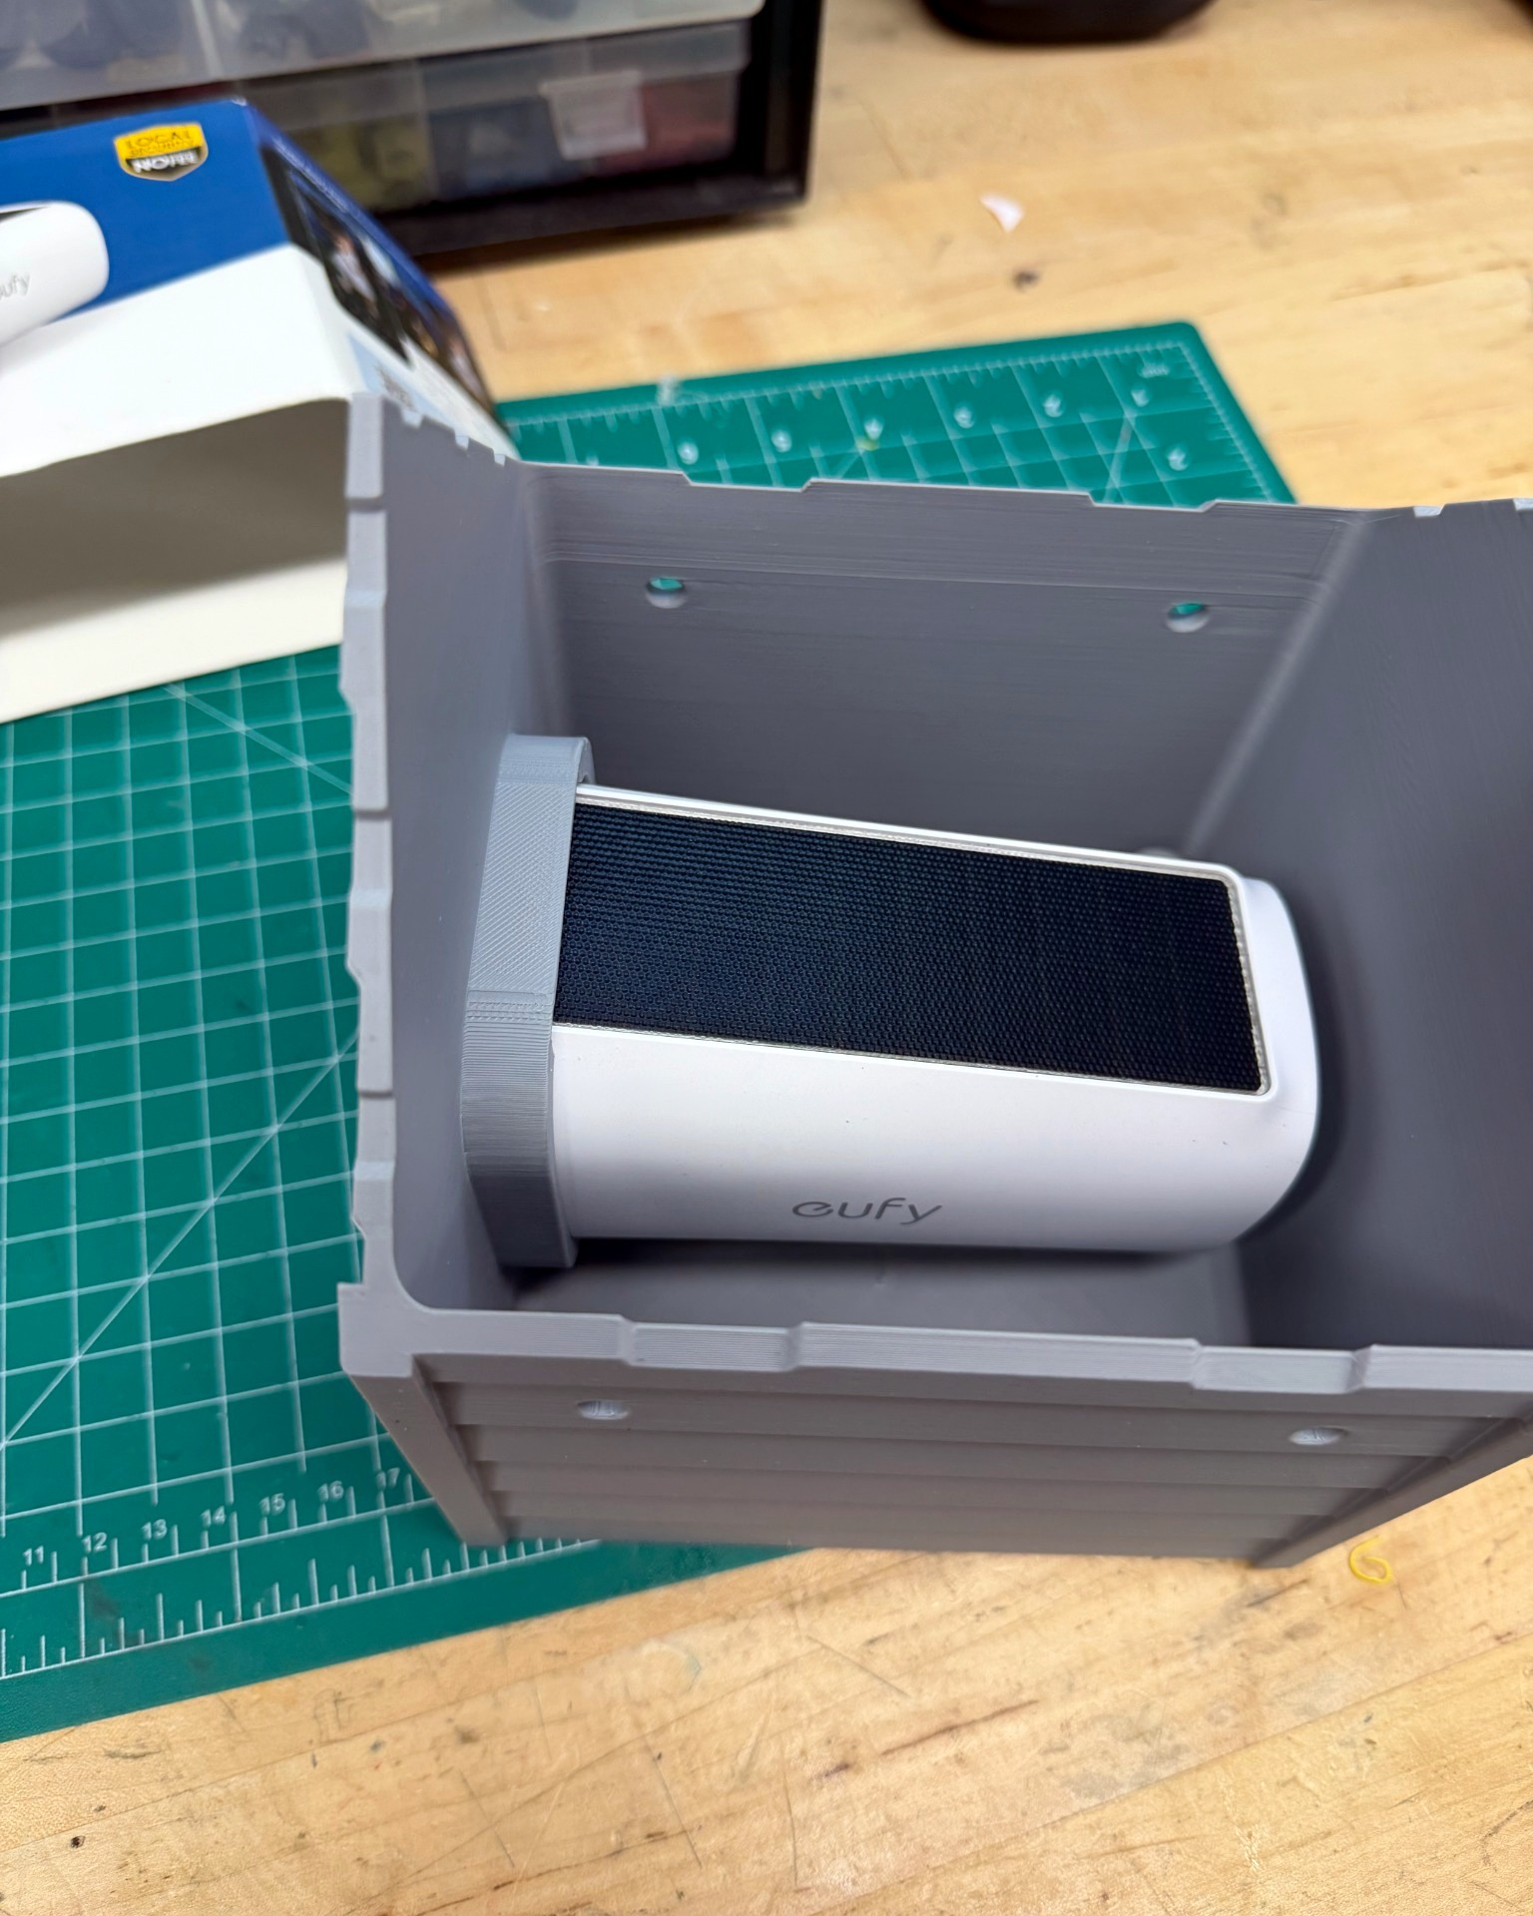
Step 1 – Angle the camera downward | Step 2 – Straighten the camera | Final position – Slide forward until seated

